**DAILY ONLINE ACTIVITIES SUMMARY**

|  |  |  |  |  |  |  |  |  |
| --- | --- | --- | --- | --- | --- | --- | --- | --- |
| **Date:** | **23/06/2020** | | | | | **Name:** | **Lavanya D M** | |
| **Sem & Sec** | **4th & ‘A’** | | | | | **USN:** | **4al18cs041** | |
| **Online Test Summary** | | | | | | | | |
| **Subject** | | **Webinar quiz** | | | | | | |
| **Max. Marks** | | **15** | | **Score** | | | **8** | |
| **Certification Course Summary** | | | | | | | | |
| **Course** | **Creating blog** | | | | | | | |
| **Certificate Provider** | | | **Bitdegree** | | **Duration** | | | **1week** |
| **Coding Challenges** | | | | | | | | |
| **Problem Statement:**  1) Python Program to Split the array and add the first part to the end There is a given an array and split it from a specified position, and move the first part of array add to the end  2) Write a C Program to Sort a stack using a temporary stack | | | | | | | | |
| **Status: Complied** | | | | | | | | |
| **Uploaded the report in Github** | | | | | **yes** | | | |
| **If yes Repository name** | | | | | <https://github.com/lavanyamurthi/lockdown-coding> | | | |
| **Uploaded the report in slack** | | | | | **yes** | | | |

Online Test Details: (Attach the snapshot and briefly write the report for the same)

**Webinar:**

Today webinar class is conducted on IOT by Sushanth sir in which we learn about the IOT concept, and even we had test

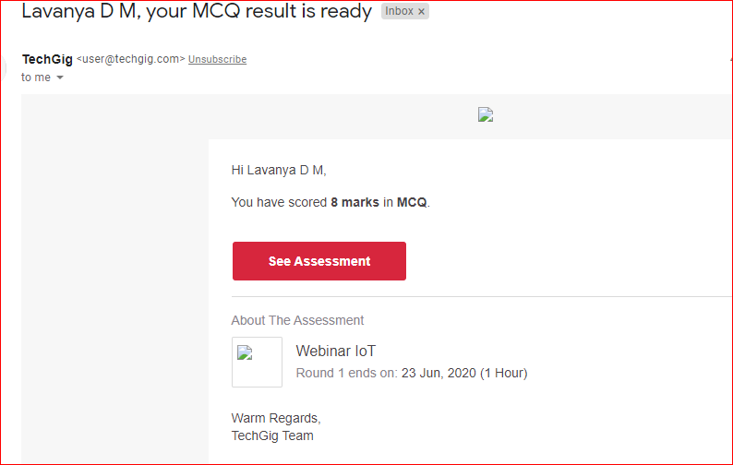

Certification Course Details: (Attach the snapshot and briefly write the report for the same)



Coding Challenges Details: (Attach the snapshot and briefly write the report for the same)

**Problem 1** : Python Program to Split the array and add the first part to the end There is a given an array and split it from a specified position, and move the first part of array add to the end.

Examples:

Input : arr[] = {12, 10, 5, 6, 52, 36}  
k = 2  
Output : arr[] = {5, 6, 52, 36, 12, 10}  
Explanation : Split from index 2 and first  
part {12, 10} add to the end .

Input : arr[] = {3, 1, 2}  
k = 1  
Output : arr[] = {1, 2, 3}  
Explanation : Split from index 1 and first  
part add to the end.

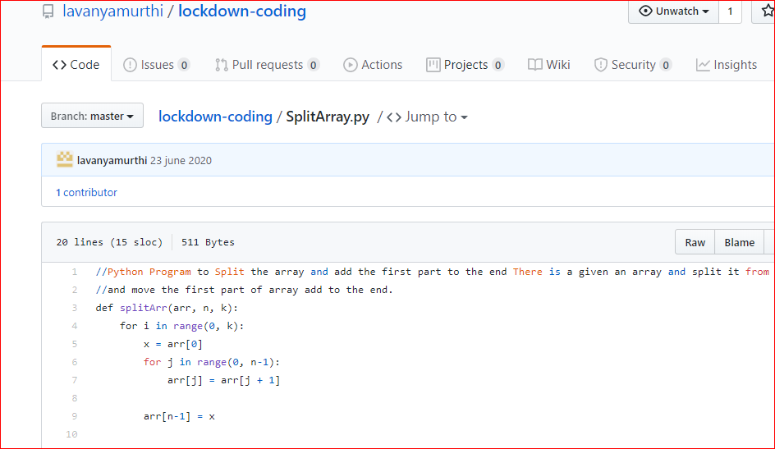

**Problem 2:**  Write a C Program to Sort a stack using a temporary stack

We follow this algorithm.

1. Create a temporary stack say tmpStack.
2. While input stack is NOT empty do this:  
   • Pop an element from input stack call it temp  
   • while temporary stack is NOT empty and top of temporary stack is greater than temp,  
   pop from temporary stack and push it to the input stack  
   • push temp in temporary stack
3. The sorted numbers are in tmpStack

